1 blue folder; Pre-sharpened #2 pencils, 1 pack crayons, 4 boxes tissues, 2 clorox wipes, 2 paper towel rolls, 1 pink eraser Quintin, 2 packs-Expo Dry Erase Marker Chisel tip BLACK only
(4-pack: black)
1st Grade Supply List 2024-2025
***Please do not label items with student’s name

 | Quantity | Item
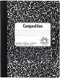 | 2 | Composition Books (speckled, bound not spiral)
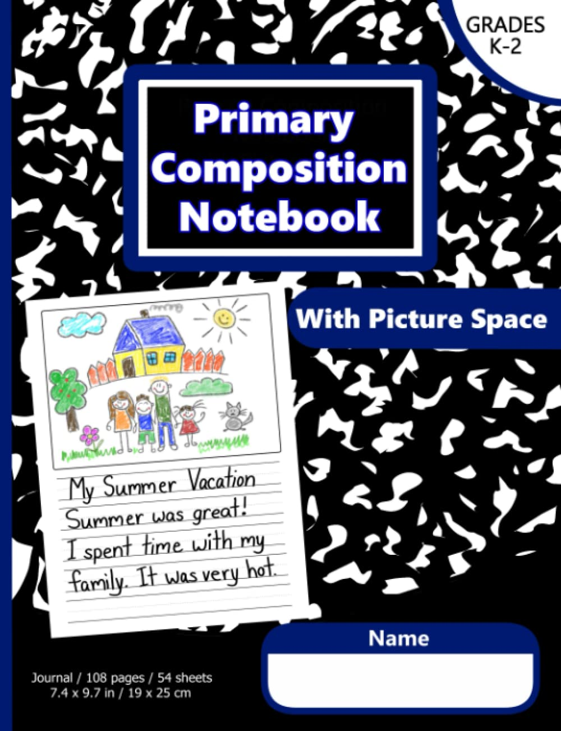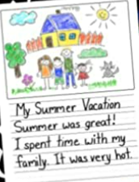 | 2 | Primary Composition Notebook: Primary Story Journal with Dotted Writing Lines and Blank Picture Space at top for Grades K-2.  *Can be found on amazon  Link: https://a.co/d/f49FK40
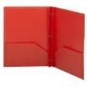 | 3 | 2-POCKET PLAIN PLASTIC folders with 3 PRONGS  1 red and 1 blue
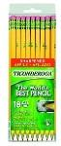 | 2 packages | Pre-sharpened #2 pencils
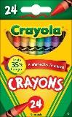 | 2 packs | 24 pack of Crayola crayons
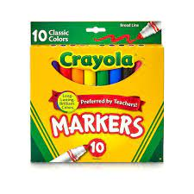 | 1 pack | 8 or 10 pack of classic Crayola markers (regular size - not skinny)
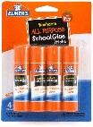 | 2 | Glue sticks (jumbo)
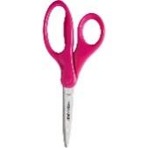 | 1 pair | Child scissors (blunt tip)
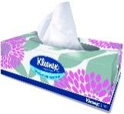 | 2 boxes | Kleenex tissues (family size)
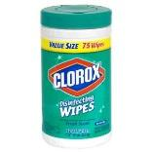 | 1 large | Clorox Wipes
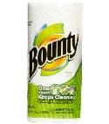 | 1 - BOYS | Paper Towel Roll
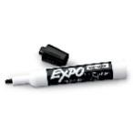 | 1 | Expo Dry Erase Marker Chisel tip BLACK only  (4-pack: black)
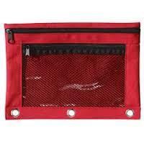 | 1 | Zippered pencil pouch - must be able to hold a lot of supplies!
 | 1 | corded headphones (earbuds or over-the-head)
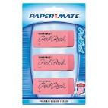 | 1 package | 3pink erasers
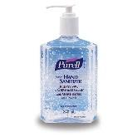 | 1 - GIRLS | Hand sanitizer

